My project is based on a career as a
Finance College Professor

Bennie D. Waller
wallerbd@longwood.edu
For partial fulfillment of FINA250 requirements
July 1, 2015

Introduction:
The career in which I intend to pursue is becoming a Finance college professor. Be sure to include all relevant information in the pursuit of and achieving this career
- Amount of education required (discuss the difficulty of getting this education, for example, cost of the education, and difficulty of getting into a university that offers such and education).

Lifestyle that the salary of a Finance Professor will provide
Given that professors generally only work 9 month each year, this career will allow multiple opportunities and benefits. Some of the benefits include but are not limited to the following
- Weekends off (with few exceptions of participating in open houses)
- Summer off (if desired)
- Ability to earn extra income during summers by teaching summer school or
- Above average income
- Prestige associated with a professor

Summary
While I realize that getting a PhD in Finance is not an easy task, I believe that such a career will offer
I plan to save 15% each year for at least 5 years for my down payment and then purchase a home after I am confident that I will be awarded tenure at the University where I am teaching after graduate school. Of course this assumes that I enjoy the area and school with which I am employed.
Assumptions and calculations:
- Annual Salary: $100,000
- Credit card payments: $350/month
- Car payment: $600/month
- Student loan payment: $500/month
- I will (or will not) need to pay private mortgage insurance (PMI). I will plan on saving 15% of my income for xx years in order to avoid having to pay PMI.

28/36% calculations for qualifying for a mortgage
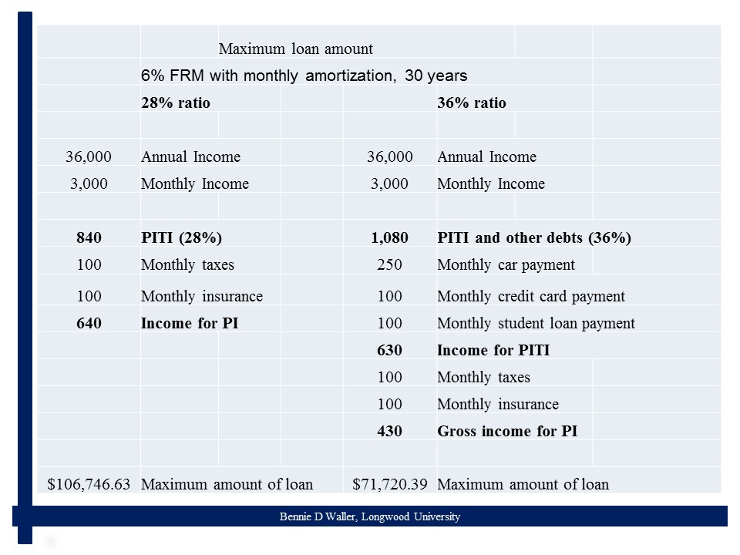

Without 20% down payment, you will likely have to pay private mortgage insurance (PMI).
 |  | Maximum home value
 | Based on 80% LTV mortgage lending guidelines
 | 28% ratio |  |  | 36% ratio
 | $106,746.63 |  |  | $71,720.39
80% LTV | $133,433.29 |  |  | $89,650.49
20% PMT | $26,686.66 |  |  | $17,930.10

Resources
http://www.bls.gov/ooh/sales/real-estate-brokers-and-sales-agents.htm
Getting into a Finance PhD program. Bennie Waller. Journal of PhD Programs, 2015, 3:1, 29-33.

